**Assignment 1 – ITC313**

**Discussion on development:**

Task2 was very easy, though a little research was needed to jog my memory since Java1. Task1 was relatively easy until I tried drawing, things just liked disappearing or not working.

**What I found hard:**

Painting was incredibly difficult. With the paint component class being different from conventional classes, it was just called and magic didn’t like happening. I started with 2 classes, one extend Jframe and then another extending Jpanel but it wasn’t until latter I figured I could one of them only and it would still work. This moving of code, made my program a mess but I’ve tried to clean it a little bit.

**Zoom:**

Zooming was a process in itself and I’m still not sure I got it right. I started with absolute numbers and then changed to factors and a distance, which seemed to work better. However sometimes the points would move to the corners or to a side, to which I’ve tried to find the fault. Needless to say, I not surprised others haven’t put it in; the relative moving distances were hard to create. Also, for some reason the jlabel’s liked putting themselves in a different location to the points, despite being set the same. I’ve added some correction but isn’t perfect as it is absolute and not relative to the number of letters, so the label are slightly placed beside to the right of the points.

Program made and complied in :

* Windows 7 64bit
* IDE for Java EE Developers 2.0.0.20130613-0530
* Runtime is java 1.7

**To run project:**

Notes: - The files should work by themselves but were compiled in eclipse, here are instructions for eclipse should any issues occur.  
- if task1 is run by self, a textfile “POI.txt” should be in the same directory  
-if task1 is run by eclipse the textfile should be in the root folder “ITC313_assign1” (the one with .classpath files etc)

1. Open Eclipse IDE for Java EE Developers
2. Open the “file” menu
3. Click “Import”
4. Expand “General”
5. Double click “Existing projects into workspace”
6. Browse for the root directory (the one with .project files etc.)
7. Import
8. On the side, expand “ITC313_assign1”
9. Expand “src”
10. Right click **Task1.java** or **Task2.java**
11. click “run as”
12. click “Run Java Application”
13. enjoy.

Task1:

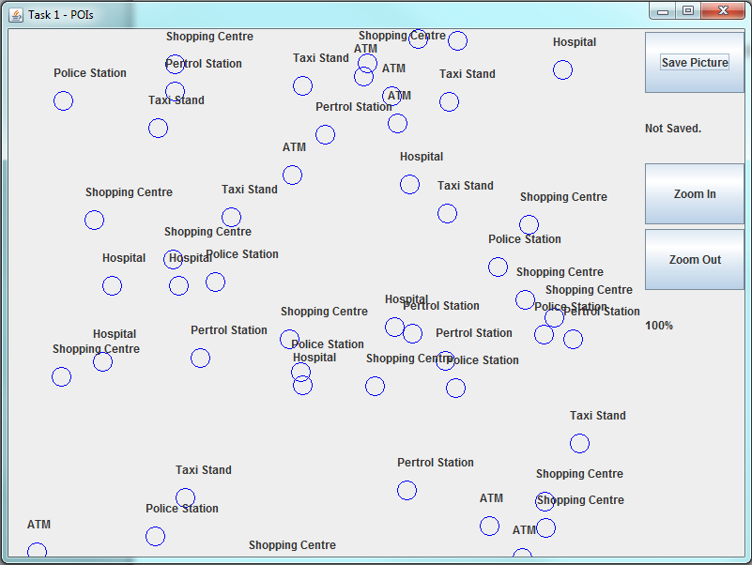

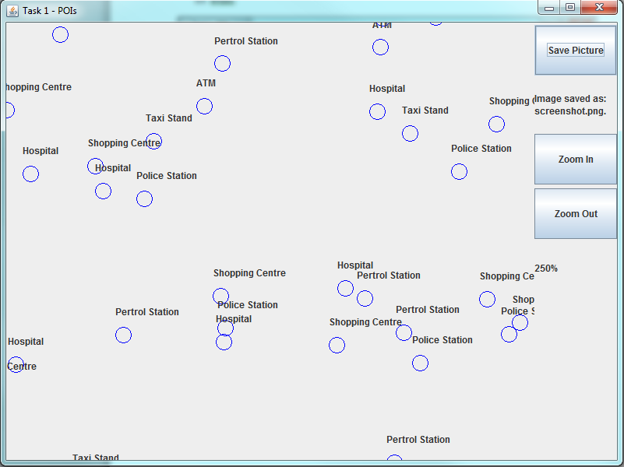

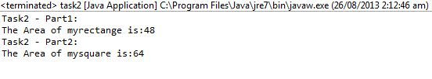Task2 (eclipse):